Requirement Analysis

Entities and their attributes

**AccountHolder:** an AccountHolder is someone that can place orders and that can give a review of the products. An AccountHolder has a name, a phoneNumber, a billingAddress, a creditCardInfo and an email which is the primary key.

**Order:** An Order is placed by an AccountHolder and consists of ItemInstances. An Order is identified by an orderNumber (primary key) and is associated with a shippingAddress and a total representing the sum of the prices of the different ItemInstances.

**ItemInstance:** An AccountHolder buys ItemInstances which are identified by their UPC (primary key). An ItemInstance ISA ConsoleInstance, GameInstance or AccessoryInstance. It also has a price associated with it.

**ConsoleInstance:** a ConsoleInstance is a subcategory of ItemInstance and inherits the UPC (primary key) and price attributes. It is also a weak entity and its owner is Console. A ConsoleInstance also has a colour attribute.

**GameInstance:** a GameInstance is a subcategory of ItemInstance and inherits a UPC as primary key and a price attribute. It is a weak entity and its owner is Game.

**AccessoryInstance:** an AccessoryInstance is a subcategory of ItemInstance and inherits a UPC as primary key and a price attribute. It also has a colour attribute. . It is a weak entity and its owner is Accessory.

**Game:** a Game is associated with a releaseDate, a maturityRating, a gameType and a developer. It is a subcategory of Product so it has an ID as primary key and is also associated with a name. It is the owner of the weak entity GameInstance.

**Console:** a Console is associated with a brand and a techSpecs along with an inherited ID (primary key) and a name from Product. It is the owner of the weak entity ConsoleInstance.

**Accessory:** An Anccessory has a brand and a type. It is also a subcategory of Product and has an ID as primary key and a name. It is the owner of the weak entity AccessoryInstance.

**Product:** A product is identified by an ID which is its primary key and has a name. A Product ISA Game, Console or Accessory. A Product is reviewed by an AccountHolder.

**Warehouse:** a WareHouse ISA StoreLocation and is identified by a StoreNumber (primary key). It also has an address. A warehouse has ItemInstances in stock.

**StoreLocation:** a StoreLocation is a subcategory of Warehouse so it inherits its primary key storeNumber and its attribute address. It also has openingHours.

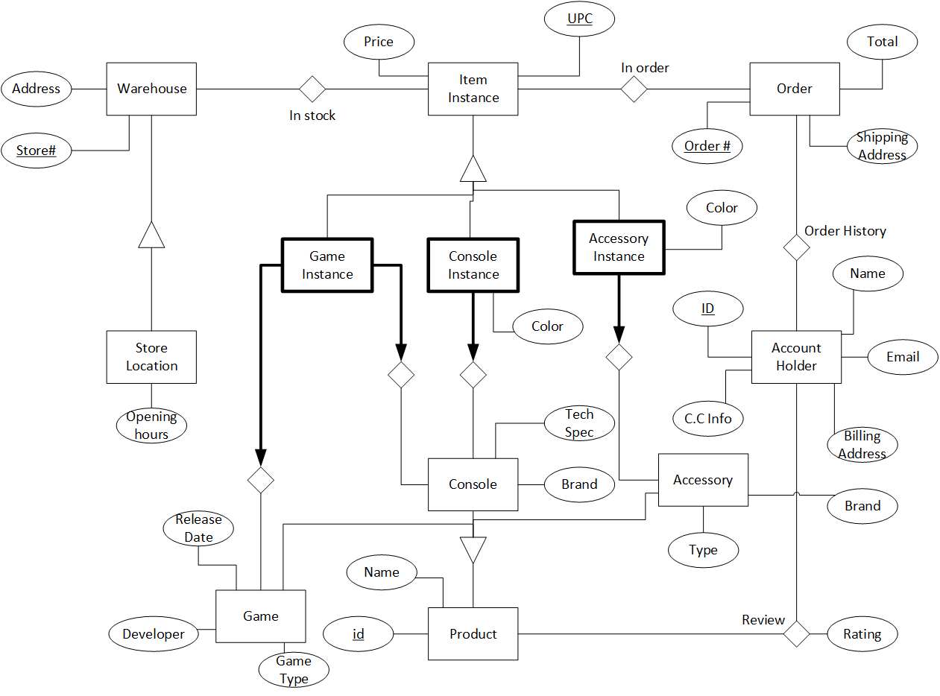

Relations

**Entities:**

Warehouse (Store#, Address)

ItemInstance (UPC, Price)

Order (Order#, Total, Shipping Address)

StoreLocation (Opening hours)

AccountHolder (ID, Name, Email, C.C info, Billing Address)

Accessory (Type, Brand)

Console (Tech spec, Brand)

Game (Release Date, Developer, Game Type)

Product (id, Name)

**Weak Entities:**

GameInstance

ConsoleInstance (Color)

AccessoryInstance (Color)

**Relationships:**

InStock

InOrder

Review (Rating)